A.
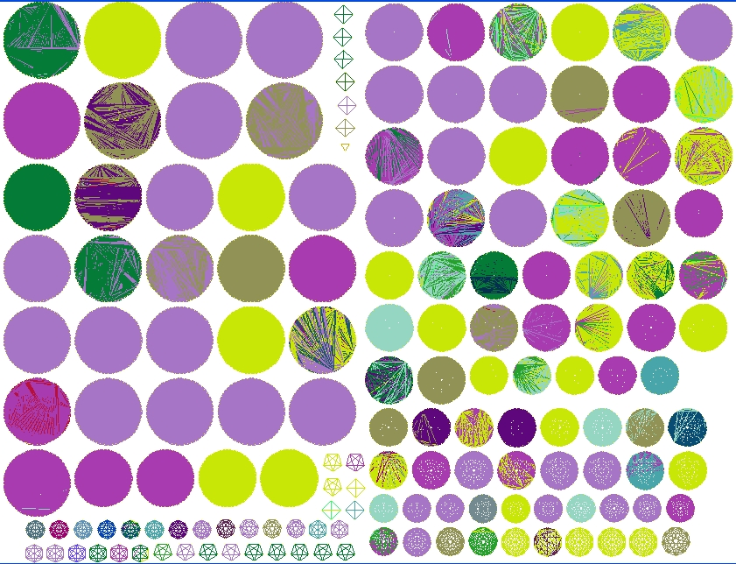

B.
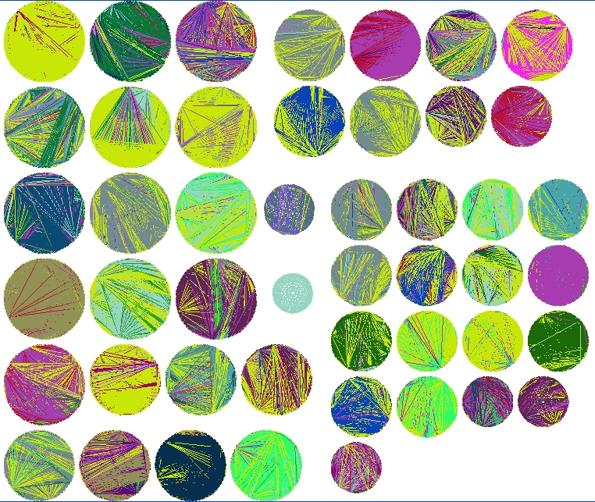

Figure XX. Comparison of modules identified by IDF and UncCorr
Overview of modules identified in networks constructed using IDF and UncCorr similarity metrics (see Methods.) Colored edges link gene pairs for each shared phenotype. Each phenotype has its own color. Selected color key: EMB (light purple), UNC (yellow), STE (light purple), LET (light blue.)

